Unit 6: The Road to Revolution
Empresario named ______________ _______________, a ____________ __________________, had a colony near present day Nacogdoches.
Mexican officials heard of the illegal arrests and _____________ were sent to Nacogdoches.
The rebels in the Edwards colony proclaimed a new independent state called the _______________________ _____ _______________________ and signed a Declaration of Independence on December 21,____________.
The Fredonian Rebellion worried Mexican officials & thought it was part of an ________________ _____________ to acquire Texas.
An inspection party led by General _____________ ______ ________ ____ ____________was sent to Texas.
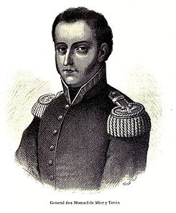
In his report, Mier y Teran expressed concern over the _____________ influence in Texas and said that prompt _________ was needed.
Mier y Teran suggested:
Troops be sent around the _____________________
Work to attract more Mexican and __________________ settlers
Develop more ______________ between Texas and Mexico
In _________________ to Mier y Teran’s report, the __________ _____ __________ ____ , ________ was passed.
Mexico _______________ this would ______________ Mexico’s ____________ over Texas.
Key Points of the Law of April 6, 1830
Outlawed ____________________________ from the United States
Cancelled incomplete __________________ with empresarios
Encouraged immigration of Mexicans & _______________________ to Texas
Forbade ____________________ people from being brought into Mexico
Established new ________________
Added ________________ to all foreign goods entering Texas
Hundreds of troops stationed in Texas to enforce the Law of April 6, 1830.
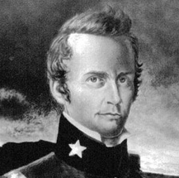
The biggest objection to the troops being there was that Colonel Bradburn tried to __________________ the duty on goods _____________________ by ship into Texas.
Tensions rose in _________________ between Texans and Mexican officials due to import taxes and the arrest of ______________ ____. ____________________ & Patrick C. Jack.
A small __________________ occurred between the Texans and Mexicans.
Texas __________________________________ received news that Santa Anna won a battle in Mexico.
This news caused the Texans to adopt the _________________ _______________ ______________________on ____________ _____, ___________.
It was not a _________________ against the government but a defending of their rights under the ________________________________.
In the resolutions, Texans declared their _______________ to Mexico, but not the __________________ ___________________________.
During the ___________ and minor exchange of _______________ at Anahuac (prior to the resolutions), some of the men left to find a _______________ in the town of Brazoria.
____________ that the resolution had been filed and the conflict was _________, the men headed back to Anahuac.
When they reached __________________, the Mexican officials would not let them pass resulting in The _________________ of _______________ on ____________ ______, __________.
The ___________________ army soon ran out of ammunition and surrendered to the _______________ colonists.
____________-__________ ___________________________from Anglo American settlements met in San Felipe.
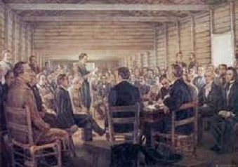
____________________ _____. ________________ led the convention as president.
Convention of 1832 Proposals
Resume _________________________ from the United States
Texas to be exempt from import duties for________________ years
Asked that Texas be made a separate ________________ of Mexico
Second convention was called in _______________ of __________ in San Felipe.
______________ __________________________represented Nacogdoches.
The Convention of 1833 adopted resolutions like the ones adopted the year before, except this meeting drew up a constitution for the proposed state.
Stephen F. Austin, ___________________ ________________, and Dr. James Miller were chosen to present the resolutions in Mexico City.
Austin set out on a mission to __________________ __________to present the ___________________ established in the Conventions of __________ and ___________ to Santa Anna in April of 1833.
Because of other issues the nation was facing, ______________ ____________________ and the congress could not meet to discuss _________________ demands until November.
In October, Austin (very frustrated) wrote to the ________________ government ordering them to go ahead and __________ organizing a state _____________________; even though that demand had yet to be ______________.
When ____________ finally was able to meet with ____________ _____________, all the demands from the conventions were granted ____________ Texas being made into a __________________ state.
Austin was satisfied and ______________ to Texas only to be _______________ by Mexican officials who intercepted the ____________ he had written.
Austin was ______________ for a year (without trial) for “__________________ the Mexican _________________”
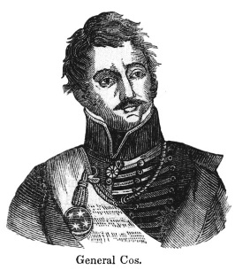
The actions by _________________ ________________ _____ _________ caused concern and angered the Texans. A convention was called to discuss the situation.
The Consultation was to take place in October at _____________________-______-_______-_______________.
The _________ __________worried that the meeting would lead to trouble. The _______ ___________favored the meeting.
Stephen F. Austin was in favor of the Consultation as he was convinced Santa Anna was becoming a __________________.

