Texas Empresario Map
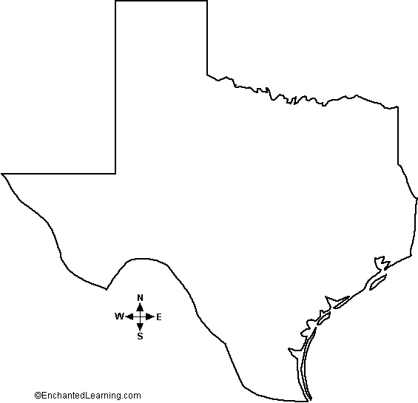
Draw the following empresario settlements on the map below. On the line next to the item, please indicate the year of the contract. Use page 200 in your book as a reference.

KEY
____Austin _________
____Austin & Williams _________
____Austin’s Colony _________
____Burnet _________
____Cameron (1st) _________
____Cameron (2nd) _________
____De Leon _________
____Dewitt _________
____Filisola _________
____McMullen & McGloin _________
____Milam _________
____Power & Hewetson _________
____Vehlein _________
____Wavell _________
____Woodbury _________
____Zavala _________

